03/03/2023 Shreyas Belkune sb2660@rit.edu

Project 3

# Task 1

# Code has been attached with the zip

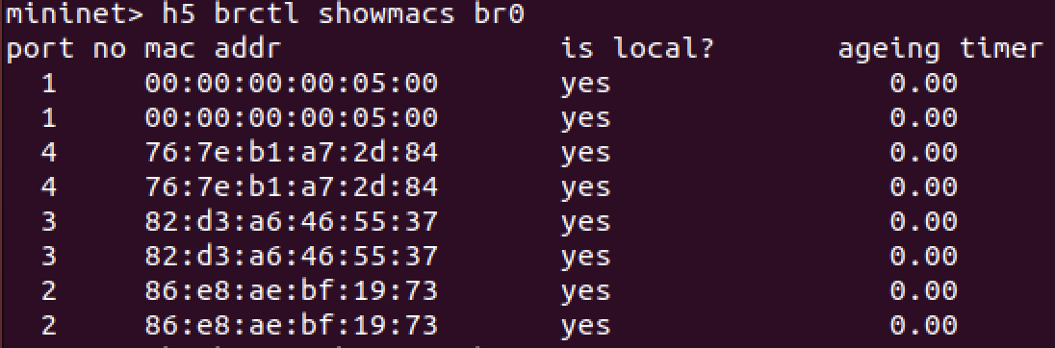

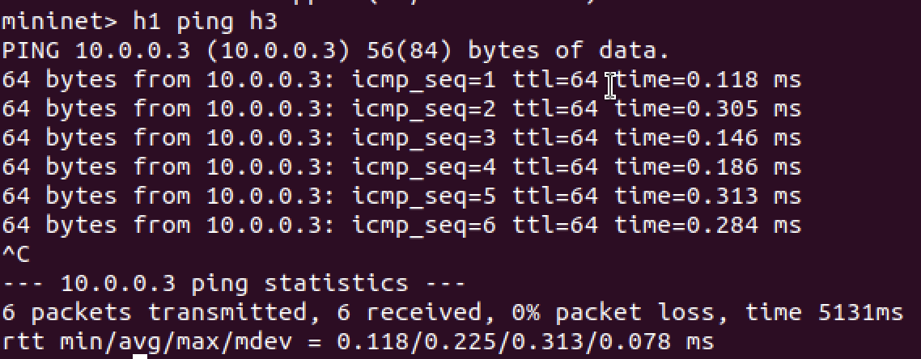

# Task 2

# Bridge Logs are attached with the zip. (Host logs too big to be attached, hence screenshot attached)

Ageing timer drop can be seen prominently.

# Task 3

# OBSERVATIONS

## TASK 1 –

### We configure everything and check if everything works by using the ping command.

### We use python to configure our host and bridge.

### We check the bridge connections and mac address of all hosts connected.

## TASK 2-

### We run bridge monitor command to check for the log entries that are been added and discarded from the table by running the relevant command.

### We save the logs in a file(attached in the zip).

### We do a TCPDump by adding the relevant code in the py file and the output of the same is stored in h1.text file (attached in the zip)

### Now we ping all and print the forwarding table.

### We repeat the above step again and we see a considerable difference in the ageing table.

## TASK 3-

### Install iperf packet.

### We run the iperf commands.

### We look at the outputs carefully.

### We run the iperf commands again with setageing set to Zero.

### We look at the output again and we see that there is a drop in the Bandwidth